The Xixia Avatamsaka Sutra
Dafang guangfo huayanjing 大方廣佛華嚴經
Chapter 41

This chapter of the Avatamsaka Sutra comes as a long, accordion-fold book (or jingzhe zhuang 經摺裝: literally a "sutra binding") mounted at both ends on small boards covered with brocade. The text is in Xixia (or Tangut) script. It is a woodblock-printed book dating to the 13th or 14th century with an illustrated frontispiece. It is Chapter (juan卷) 41 of the Avatamsaka Sutra or Floral Garland Sutra or Flower Adornment Sutra, in Chinese Dafang guangfo huayanjing 大方廣佛華嚴經 [the Siksananda translation in 80 juan]

A brief presentation of the Avatamsaka Sutra

The Avatamsaka Sutra or Floral Garland Sutra or Flower Adornment Sutra, in Chinese Dafang guangfo huayanjing 大方廣佛華嚴經, in Japanese Kegonkei 華厳経.

This sutra is very important to the Mahayana Buddhist tradition of China, Japan and Tibet. It is a very long text composed of different parts brought together in Central Asia during the 3rd or the 4th Century A.D. Only fragments of the Sanskrit version remain today, but the whole Chinese version is available.
It actually consists of three different versions and two parts, which are also considered independent sutras themselves
The three different versions are:
- The 60 juan (roll or chapter) version, Liushi Huayan 六十華嚴, which was translated by Buddhabhadra 佛陀跋陀羅 (359-429) around 420 A.D. (Eastern Jin).
- The extended 80 juan version, Bashi Huayan 八十華嚴, which was written by Siksananda 實叉難陀 (652-710) around 699 A.D. (the so-called Zhou dynasty of Wu Zetian). Fazang 法藏 (643-712), the famous Chinese master, took part in the translation. The Chapter 41 in the library’s collection belongs to this version.
- The 40 juan version, Sishi Huayan 四十華嚴, was translated by Prajñā 般若 (734–?) around 798 A.D. (Tang).

- The 26th Chapter of the Sutra is also known as the Ten Stages Sutra (in Sanskrit: Daśabhūmikasūtra-śāstra; Chinese: Shidijing 十地經). Written by Vasubandhu 世親 (3rd - 4th century A.D.), it was translated into Chinese a first time in the 3rd century A.D. and a second time in the 6th century A.D. by Bodhiruci 菩提流支 (fl. 6th century A.D.)
- The last chapter of the Avatamsaka Sutra also circulates as a separate text known as the Gandavyūha Sūtra; Chinese: Huayanjing rufajiepin 華嚴經入法界品. It details the journey of the youth Sudhana 善財童子, who undertakes a pilgrimage in 52 stages and 53 visits at the behest of the bodhisattva Manjushri 文殊師利.

This Sutra as been from early times regarded as the most important text of the Buddhist canon because it is said to have been written by the Buddha himself after he has reached enlightenment. It describes a cosmos of infinite realms upon realms mutually containing each other. Its cosmological content is actually hard to grasp. The Chinese Huayan Buddhist School is based on an interpretation of this Sutra made coherent and compatible with traditional Chinese thought.

A description of the our original copy illustrated with photos
The text in Xixia script

The Xixia
Initially based in northwestern Sichuan and southern Gansu provinces, the Tangut around the end of the 8th Century A.D. were a nomadic people under the domination of the Tibetan Empire. Later, under the Chinese pressure on Tibet, the Tangut moved to the north to Ningxia. There they controlled the Silk Roads and the passes from Central Asia to China. Controlling this new area made them rich and more and more powerful. Around 1028, the Tangut extended their domination over the Uyghur kingdom in Gansu and founded an Empire they named Xia, whose capital was established in Ningxia (at present-day Yinchuan 銀川). They controlled West Mongolia, the Ordos up to Shanxi, and Shaanxi. They had become so powerful that the Song dynasty had to negotiate a truce in 1044, and the Xixia (西夏, or Western Xia) remained a threat until they were defeated by Genghis Khan in 1227. Their empire had 10 emperors over a period spanning some 190 years (1032 to 1227).
They were highly sinicized, which means they had a strong administrative centralized state based on the Chinese model.
In the 12th Century, the Tangut rulers, careful to distance themselves from the Chinese, began to use Tangut as the official language and created their own writing system. They also ordered that classical Buddhist and Chinese texts should be translated. Tibetan Buddhism was the state religion.

Their language and script
The Tangut language belongs to the Tibeto-Burman family and is nowadays extinct.
The Xixia 西夏 script
The Chinese writing system served as conceptual model for the Tangut script. The Tangut script Xīxià Wén 西夏文is a heterographic syllabary, which is to say that the writing is phonographic and syllabic (syllabographic), with 126 syllables. Both cursive and square forms of Tangut writing are known, though the standard writing is the latter.
After the disappearance of the Xixia Empire, the Xixia script remained in use. It was renamed Hexizi 河西字 during the Yuan Dynasty and used to print huge quantities of Buddhist texts using movable fonts. They are also remaining copies of the Tangut Lotus Sutra.

Our copy of Chapter 41
It was stored in a small side room, where I found it wrapped inside a cardboard box. There was no stamp and no inventory number on it. We don’t know how it came to our library and have no way of knowing it. My guess is that it was brought back to France by Paul Pelliot and stored with other documents at the library of the Institut des Hautes Études Chinoises which, at the time, was administered by the Sorbonne and didn’t belong to the Collège de France (the transfer took place in 1972). The library changed location twice after that, and the Sutra was moved with a number of other items without anybody taking notice of what it was.
When I discovered it, professor Jean-Pierre Drège a retired senior researcher and former director of the EFEO, helped me determine what it was. I haven’t been through the archives of our institute and will do that, but I doubt I will find information about the origin of this document.
Of further interest
I would like know if anyone here can tell me if there are any other original copies of Xixia texts in European libraries, either religious or other texts. BnF holds in its collections texts in xixia script, as well as St Petersbourg’s.

The front cover

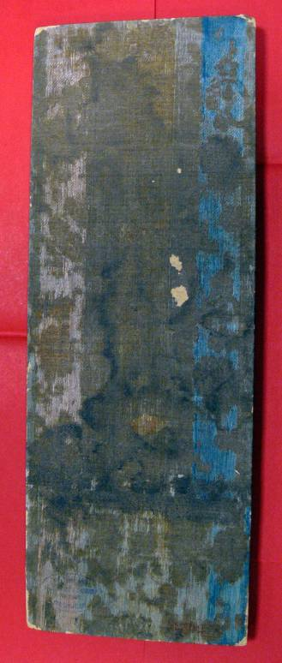

The image mounted before the frontispiece
It represents the 8th assembly, an episode of the sutra,
which takes place in the Prince Jeta’s garden.
In the center is the Buddha Vairocana (the supreme or celestial Buddha) with Samantabhadra (a bodhisattva), Manjusri (the bodhisattva of transcendent wisdom) and disciples
The three are often associated together and form the Shakyamuni trinity

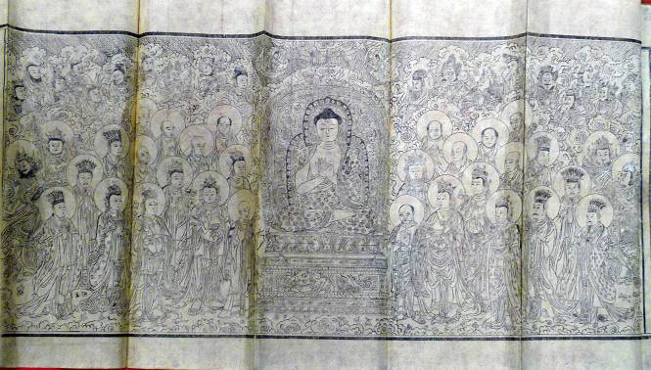

The Frontispiece and the Beginning of the Sutra.

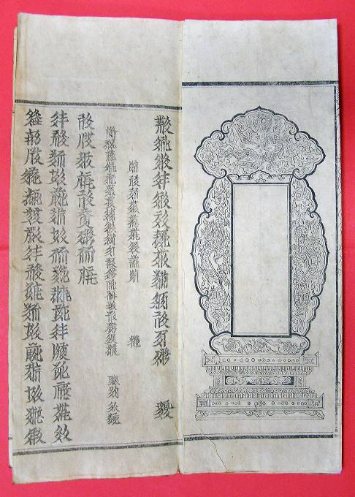

The text of the Sutra

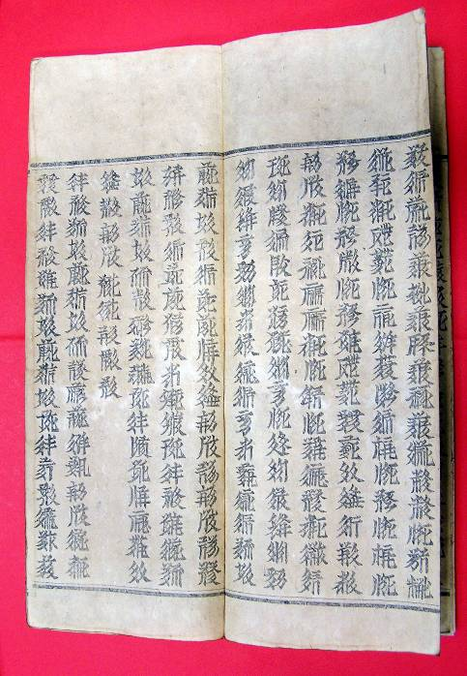

The last pages

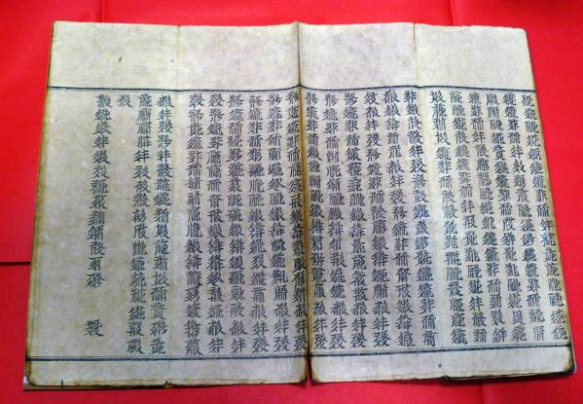

The Xixia syllabary (in Spanish transcription)

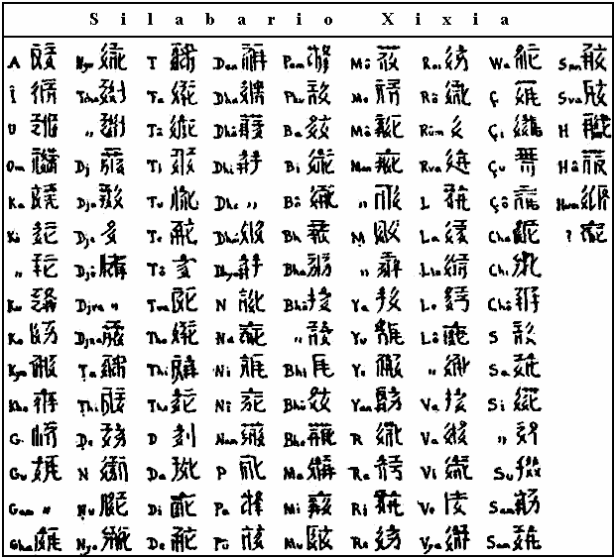

Also called番文 Fān Wén, or 唐古特文 Tánggǔtè Wén
For more information about the representations of Buddha in Xixia Sutra, see Jean-Pierre Drège, « De l’icône à l’anecdote : les frontispices imprimés en Chine à l’époque des Song (960-1278) », Arts Asiatiques, 1999-54, pp. 44-65.

